Program Management Office (PMO)
Process Improvement Guideline

Revision Date: July 1, 2002
Revision: 2.1
Product Code: GTA-PMO-GLI-011

Table of Contents
1.0 Process Improvement Guideline 1
1.1 Key Process Area Purpose 1
1.2 Guideline Purpose 2
1.3 Definitions 2
1.4 Process Owner 3
1.5 General Logic 3
1.6 References 4
1.6.1 Principles 4
1.6.2 Guidelines 4
1.6.3 Guidebooks 4
1.6.4 Templates, Checklists, Forms 4
1.6.5 Third Party 4
1.7 Procedural Overview 5
1.8 Goals 5
1.9 Responsibilities 5
1.9.1 Leadership Committee 5
1.9.2 Program Management Office 5
1.9.3 Individuals Submitting PILLs 6
1.10 Activities 7
1.10.1 Process Improvement Submitted 7
1.10.2 Program Management Office Prioritizes Request 8
1.10.3 Working Group Formed 8
1.10.4 New and Current Process Evaluated 8
1.10.5 New Process Documented 8
1.10.6 Pilot Selected/Training Completed 8
1.10.7 Rollout Completed 8
1.10.8 Process Becomes Standard 8
1.11 Measurement 9
1.12 Verification 9

Table of Figures
Figure 1: Continuous Improvement Cycle 7

List of Appendices
None.

Revision History
Revision Number | Date | Comment
1.0 | February 9, 2001 | Original Scope and Initial Baseline
2.0 | February 28, 2002 | PMO Refinement
2.1 | July 1, 2002 | Wording change “policy to principle/procedure to guideline”

1.0 Process Improvement Guideline

1.1 Key Process Area Purpose
A. This guideline applies to the following knowledge areas:
Knowledge Area | Applicable?
Integration Management | Y
Scope Management | Y
Time Management | Y
Cost Management | Y
Quality Management | Y
Human Resources Management | Y
Communications Management | Y
Risk Management | Y
Procurement Management | Y

B. The purpose of integration management is to ensure coordination of the different elements of a project to achieve the needs and expectations of project stakeholders. It includes project plan development, project plan execution, and integrated overall change control.
C. The purpose of scope management is to ensure the work performed in a project is necessary to the successful completion. It includes initiation, scope planning, scope definition, scope verification, and scope change control.
D. The purpose of time management is to ensure a project completes in a timely manner. It includes activity definition, activity sequencing, activity duration estimating, schedule development, and schedule control.
E. The purpose of cost management is to ensure a project completes within its approved budget. It includes resource planning, cost estimating, cost budgeting, and cost control.
F. The purpose of quality management is to ensure the products and services produced by a project satisfy the needs for which the project was undertaken. Quality – the satisfaction of project needs – is a measure of adherence to stated requirements combined with fitness for use. The Quality Management Knowledge Area includes quality planning, quality assurance, and quality control.
G. The purpose of human resource management is to ensure effective use of the people involved in a project. It includes organizational planning, staff acquisition, and team development.
H. The purpose of communications management is to ensure timely and effective control flow of information for a project. It includes communication planning, information distribution, performance reporting, and administrative closure.
I. The purpose of risk management is to ensure the identification, analysis, and appropriate response to the risks encountered by a project. It includes risk management planning, risk identification, qualitative risk analysis, quantitative risk analysis, risk response planning, and risk monitoring and control.
J. The purpose of procurement management is to ensure effective acquisition of products and services from sources external to the project’s organization. It includes procurement planning, solicitation planning, solicitation, source selection, contract administration, and contract closeout.

1.2 Guideline Purpose
The purpose of this guideline is to identify the principles of process management, and to define the guideline for submitting process improvement ideas.

1.3 Definitions
Term | Definition
Baseline | (1) The complete set of related project assets in the version that was current for each asset at the specific point in time when the set was placed under configuration management control. Formal baselines are established each time project stakeholders give approval and signoff to plans, products, and services. Informal baselines are established to provide a controlled environment for auditing or testing products or services. (2) The act of creating a controlled set of related project assets.
Configuration Management (CM) | (1) The disciplines that create and maintain a controlled environment that protects intellectual assets by identifying the assets being protected, allowing re-creation of the assets in any version, tracking and controlling changes over time, informing affected groups and individuals of the status and content of the assets, and supporting planning for the activities within those disciplines. (2) The group responsible for implementing those disciplines.
Lessons Learned (LL) | (1) A statement of actions taken and results obtained, derived from project experiences. (2) A specific document prepared as a project deliverable using the Lessons Learned template (GTA-PMO-TEM-018) as a model.
Project Administrator (PA) | The member of the project team with responsibility for the technical aspects of project management, control, and reporting.
Project Asset Library (PAL) | The set of reference materials and historical project assets maintained by the GTA PMO as a knowledge repository for GTA project management.
Program Management Consultant (PMC) | The GTA PMO staff member assigned to provide consultation and mentoring in integrating the discipline of Project Management into all projects.
Process Improvement/ Lessons Learned (PILL) | The mechanism for reviewing and improving principles, guidelines, forms, and templates contained in the GTA PMO Methodology.
Program Management Office (PMO) | (1) An organizational entity responsible for management and oversight of the organization’s projects. (2) As a specific reference in this document, the PMO for the Georgia Technology Authority.  Alternatively, the acronym may stand for Project Management Office, with the same meaning as definition (1), above. An organization may use both forms, with the Program Management Office generally having responsibility for multiple Project Management Offices.

1.4 Process Owner
A. The Georgia Technology Authority Program Management Office (GTA PMO) is responsible for the maintenance of this process.

1.5 General Logic
- A fundamental goal of process management is to establish, refine, and maintain a repeatable process. Repeating processes allow the processes to be improved in a continuous manner and allow information to be shared. The following guidelines allow for input from cross-organizational functions to provide learning based systemic approach to processes within the organization.
- It must be understood that most process changes are small and can be implemented easily through the process improvement process. Other more encompassing changes will require stringent processing as they may affect the strategic planning of the GTA. As a rule one must use a pragmatic approach to any guideline and while keeping the intent of that guideline. This document was written to handle large all-encompassing process change and small incremental changes that over time add value to organization.

1.6 References

1.6.1 Principles

Principle | Product Code
Project Planning | GTA-PMO-PRI-001
Project Tracking and Oversight | GTA-PMO-PRI-002

1.6.2 Guidelines

Guideline | Product Code
Program Review Guideline | GTA-PMO-GLI-200
Risk Management Guideline | GTA-PMO-GLI-202
Issues Management Guideline | GTA-PMO-GLI-201
PMP Development Guideline | GTA-PMO-GLI-103

1.6.3 Guidebooks
Process Improvement Guidebook | GTA-PMO-GUI-012

1.6.4 Templates, Checklists, Forms
Project Change Request Form | GTA-PMO-FOR-053
Process Improvement/Lessons Learned Template | GTA-PMO-TEM-018

1.6.5 Third Party
A. Cultivating Successful Software Development, Donaldson & Segel, 1997
B. Process Innovation, Davenport, 1997
C. SEI Capability Maturity Model, v1.1, Carnegie-Melon University
D. Federal Information Publication Standard 183, IDEF0
E. IDEAL: A Users Guide for Software Process Improvement, Carnegie-Melon University

1.7 Procedural Overview
Opportunities for process improvement arise in a continuous manner through the normal course of doing business.

1.8 Goals
A. Provide a mechanism for continuous process improvement.
B. Provide a flexible process, which allows all process participants to submit ideas for process enhancement.
C. Provide a mechanism for measuring process improvement.

1.9 Responsibilities

1.9.1 Leadership Committee
A. Review all-inclusive process change requests in a timely fashion.
B. Approve or reject all-inclusive process change requests in accordance with the desired results.
C. Approve resource allocation for all-inclusive process improvement development.

1.9.2 Program Management Office
A. Ongoing development of the Process Improvement Process including:
1. Process Improvement Process documentation
2. Process Improvement/Lesson Learned Forms (PILLs)
3. Process Improvement effort status
B. Processing PILLs and providing feedback to submitters in a timely and accurate manner
C. Providing adequate supplies of the PILLs
D. Maintaining the Process Improvement Process and mechanisms
E. Characterizing and assessing the maturity of the software process
F. Identification and recommendation of areas for improvement
G. Definition of appropriate process metrics
H. Design of training program that supports improvements in process quality and productivity
I. Monitor the impact of process changes on the environment

1.9.3 Individuals Submitting PILLs
A. Completing the following portions of the PILL:
1. Initiator: The initiator's name (legibly printed or typed, please).
2. Date: The date the PILL form is submitted to either the Project Manager or the Program Management Office.
3. Project: The project or task in which the issue is surfaced.
4. Life-Cycle Phase: The project phase (system analysis, software analysis, software design, etc.) in which the issue surfaced.
5. Signature: The initiator signs here.
6. Priority Processing: Check this box if, in your opinion, it is critical that this item be processed immediately.
7. Category: pick one.
a. Change: Change is checked if the submission is a new process or a change to an existing process.
b. Correction: Correction is checked for a submission, which represents a corrected or improved description of an existing process, but the actual process is not changed.
c. Technical: Check Technical if this submission is requesting a Technical Decision and is to be submitted to the PMO.
B. Submitted To: Check the box for the person to whom you will submit the completed form.
C. Sheet 1 of ___: Enter the total number of sheets submitted (including this form). Don't forget to include any other necessary supporting documentation.
D. Issue: Briefly state (one or two lines) the original problem or the suggested new process or improvement to a process, which caused you to prepare this form.
E. Resolution: Describe what you did to fix the problem, to circumvent it, and/or to prevent reoccurrence.
F. Recommendation: Suggest what should be done to ensure that future projects would not encounter this problem (or at least won't be surprised when they do).
G. Lesson Learned: Explain how this recommendation will enhance productivity on future similar projects and how you think the improvement should be objectively measured.

1.10 Activities
In order to repeat successes and improve deficiencies, the process improvement process has been established so that all associates may participate in improving the processes used by the team in day-to-day operations. This form provides a means to capture results of any activity during or just after a participant in the activity has experienced the results. The activities are as follows:

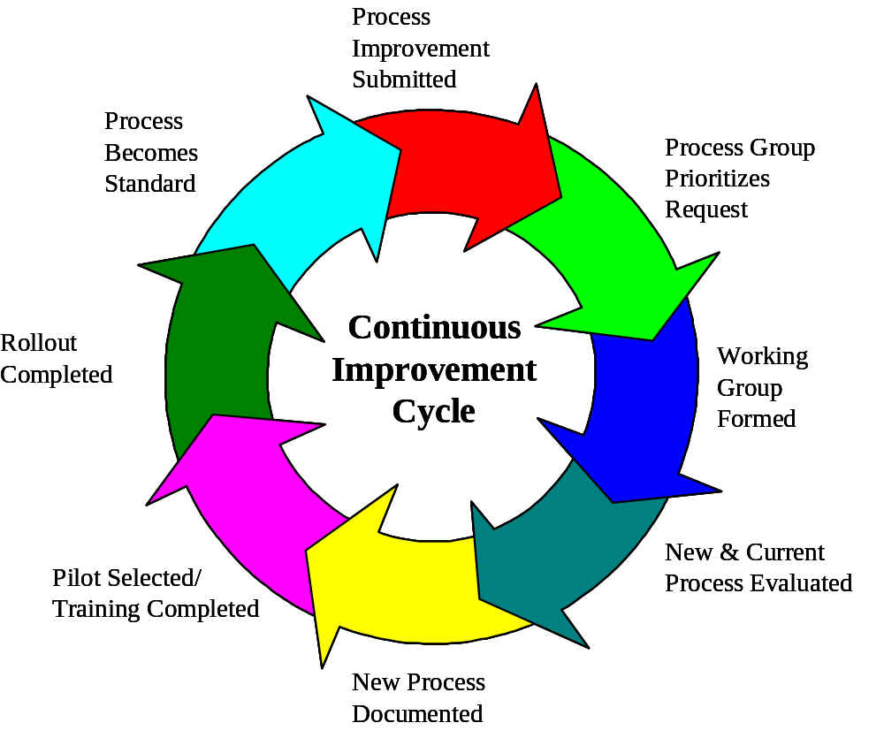
Figure 1: Continuous Improvement Cycle

1.10.1 Process Improvement Submitted
If an associate feels a particular activity can be more effective or efficient, they should complete the PILL (GTA-PMO-TEM-018). The form is then submitted to the Project Manager, Program Manager, or PMO for consideration. The same form is used to establish processes, which are not defined. If a team member feels there are particular processes that are currently undefined in the written guidelines, they may submit a request for process evaluation and documentation using the same form.

1.10.2 Program Management Office Prioritizes Request
The Program Management Office will prioritize the PILL within its program plan in accordance with the process architecture and the desires of the Leadership Committee.

1.10.3 Working Group Formed
If the process change is significant and all encompassing to the strategic planning of the GTA, the Program Management Office will charter and select a working group or person to evaluate the process under consideration. The working group or person will create a Project Management Plan for their work effort and submit it to the Steering Committee for approval and incorporation into the Integrated Project Plan.

1.10.4 New and Current Process Evaluated
If a current process exists, the working group or person will adjust the current process to accommodate the improvement. If no process exists, the working group or person will develop a new process and make provision for approval from the Program Management Office.

1.10.5 New Process Documented
The new process will be numbered and filed as a soft copy into the resources database located in the PMO.

1.10.6 Pilot Selected/Training Completed
If necessary a pilot project will be selected for all process improvements before rolling out to the remainder of the department. Large-scale changes to process without pilot projects are seldom successful. If a significant number of changes to the new process are required, a second pilot may be required in order to stabilize and tune the process prior to departmental rollout. Small process changes can be implemented without a pilot and or training.

1.10.7 Rollout Completed
The rest of the organization is trained on large-scale process change while small incremental change becomes a guide to individual projects over time through the use of the documentation from the PAL.

1.10.8 Process Becomes Standard
The process documentation, reporting and measurement become part of the departmental standard and “way we do business.”

1.11 Measurement
The Program Management Office will report status at the Program Reviews to include:
1. Number of PILLs received
2. Number of PILLs incorporated
3. Number of PILLs rejected

1.12 Verification
The PMO will ensure the processes are followed with audits of the process files periodically.

¹This document is a reference to the Georgia Technology Authority (GTA) Project Management Office (PMO) created as part of the strategic continuous process improvement initiative. Questions or recommendations for improvement to this document may be forwarded to any GTA PMO member.

